SCOPED APPLICATION INSTALLATION AND CONFIGURATION GUIDE
Genesys Cloud Connector

Table of Contents
1. Overview 3
2. Application Dependencies 3
3. Configuration Instructions 3
3.1. Configuring Genesys Cloud Connector in ServiceNow 3
3.2 Authorize ServiceNow connector’s OAuth Client in Genesys Cloud 16
3.3 Configuring Agent access to ServiceNow connector in Genesys Cloud 17
3.4 Multiple OpenFrame 18
4. Support and Troubleshooting 19
4.1 Service Level Agreement Definition 19
4.2 Troubleshooting 19

- Overview
Overview
Genesys Cloud Connector enables seamless integration between Genesys Cloud and the ServiceNow platform, offering several key features such as a Genesys Cloud widget in ServiceNow, contact search, automated interaction, incident and case creation with screen pops, HR case lookup with optional HR case creation, bi-directional data exchange, and click-to-dial functionality. This integration streamlines workflow, enhances customer service, and boosts productivity by bringing together the capabilities of both platforms within a unified environment.
This document outlines the step-by-step process for setting up the Genesys Cloud Connector, empowering users to effectively leverage its capabilities.

- Application Dependencies
- List all plugins required:
  - Open Frame Plugin
  - Plugins to support CSM features
    - Customer Service
    - Interactions Management
  - Plugins to support HRSD features
    - HR Agent Workspace
- List all system table permissions required:
  - incident
  - customer_contact
  - sn_customerservice_case
  - interaction
  - sn_hr_core_case

- Connector Setup, Roles, Permisssions, and Properties
  - Installlation and Configuration
In this section, we will detail the exact steps necessary to successfully install and configure the customer's instance following the installation of Genesys Cloud Connector from ServiceNow.
- Following the installation, verify whether the application has been successfully installed.
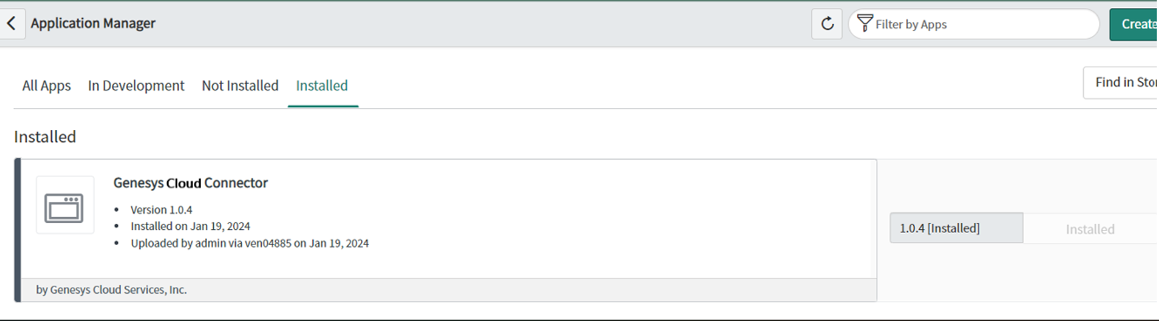
- Navigate to the Genesys Cloud Connector.
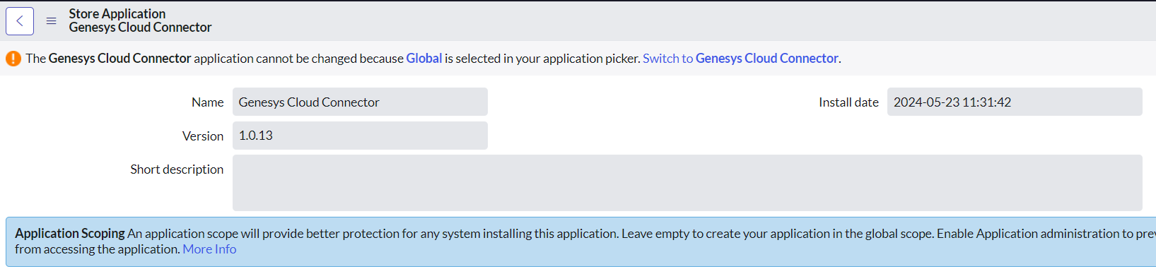
- Verify the creation of the following files:
  - Use the Filter Navigator to search for "OpenFrame".
  - Check if the "Genesys ServiceNow Connector" file has been created.
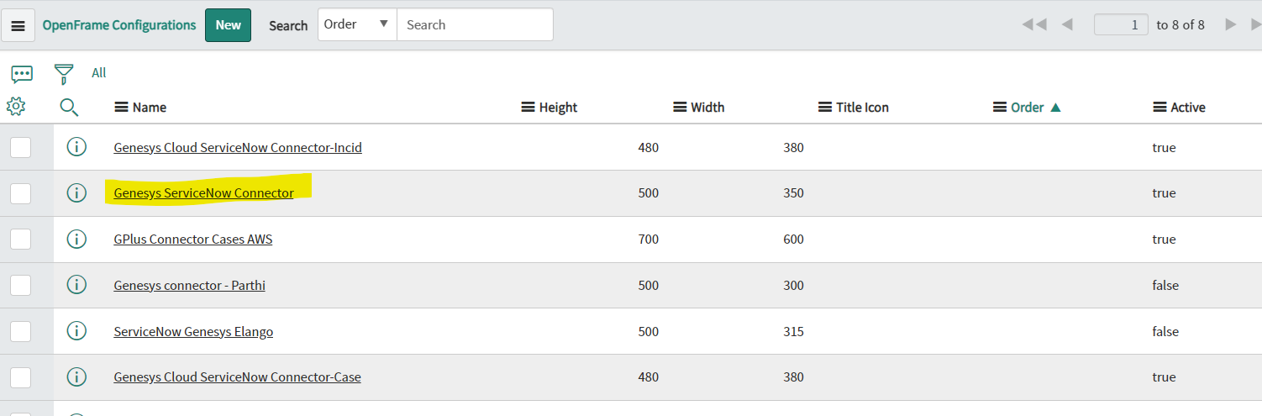
  - Ensure that the auto-created group assigned to that file is checked. Group Name: "Genesys Integration Permissions".
- Navigate to "System Definition" in the Filter Navigator and select "Script Include".
  - Verify whether the "genesys_connector_snow" file has been created.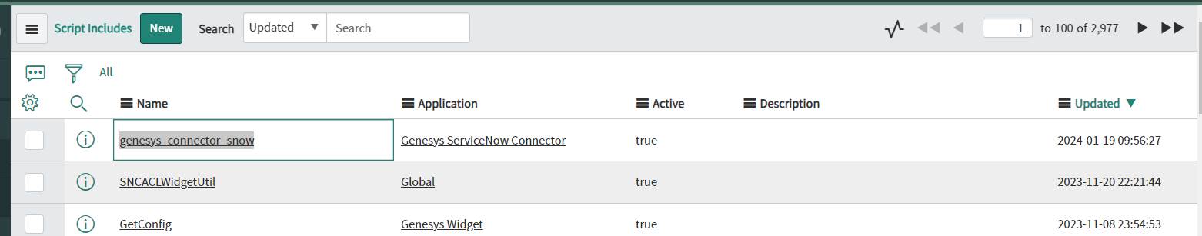
- Use the Filter Navigator to search for "UI Page" and click on it.
  - Verify the creation of the "genesys_integration_widget" file.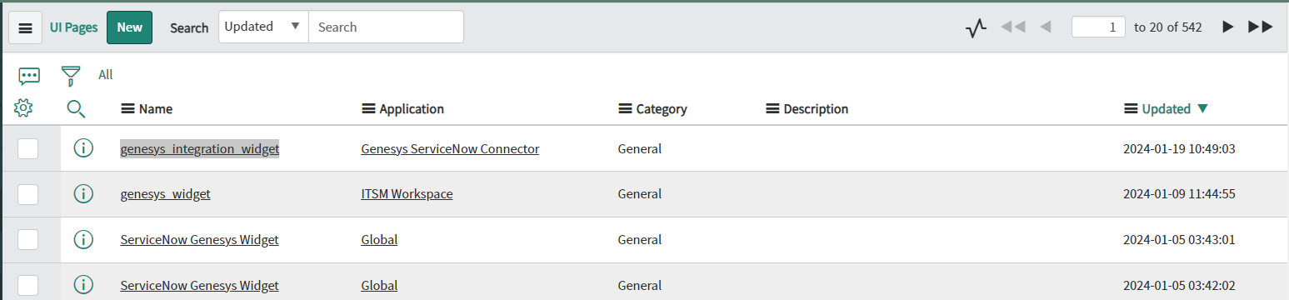
  - Verify the creation of the "genesys_help_guide" file. Open this UI page to access the refreshed in-instance help center for connector setup, configuration, troubleshooting, and release notes.
- Refresh the page and search for "Genesys Cloud Connector" in the Filter Navigator. You will find the necessary tab displayed in the navigator.
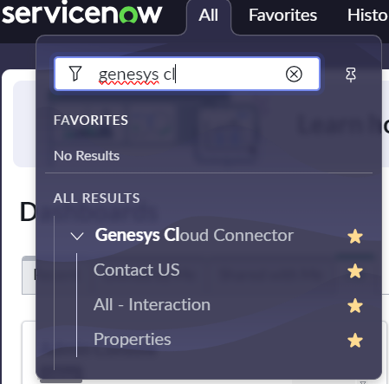
- Navigate to "User Administration" in the Filter Navigator and select "Groups".
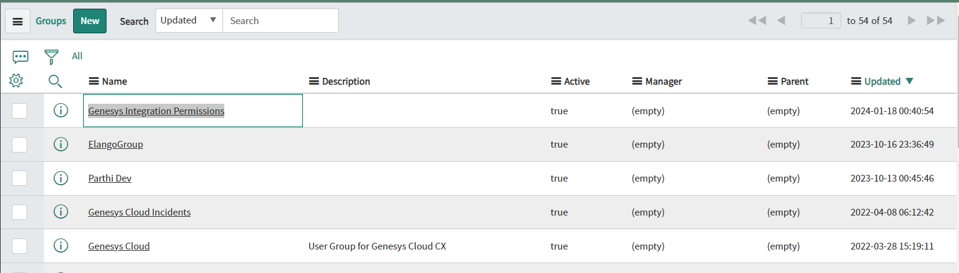
  - Search for “Genesys Integration Permissions” and Click on it. Within the tab, you'll find the "Group Members" section. Edit and assign the necessary members to manage the Genesys Connector. Update the changes and refresh the page.
  - You'll notice the Phone icon and Genesys Connector in the top right corner of the application.While login into the Genesys Connector, the widget will be visible.
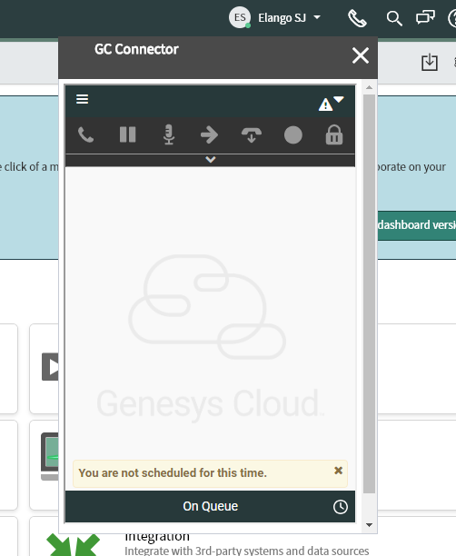

- To access the Genesys Connector, the following roles are necessary for both groups and users.
  - x_inics_gen_snow.genesys_sn_role
  - sn_openframe_user

- Modify the Connector properties to align with the screen pop and task automation requirements.

Properties | Details
Enable either Incident Creation, Case Interaction, IXN Creation or HR Case Lookup.  Property name: enableTypeOfCreation | Select any one option from the drop down list,  - enableIxnCreation  - enableCaseCreation  - enableIncidentCreation  - enableHRCaseLookup  enableIxnCreation: When this option is selected, connector creates a new ServiceNow interaction for every Genesys interaction answered.  enableCaseCreation: When this option is selected, connector screenpops the list of open cases associated with the identified contact, along with the ability to create a new case.  enableIncidentCreation: When this option is selected, connector screenpops the list of associated incidents for the identified user, along with the ability to create a new incident.  enableHRCaseLookup: When this option is selected, connector screenpops the list of associated HR Cases for the identified user. When no matching HR case exists, the connector creates a ServiceNow interaction record by default.  To automate creation of HR Case records:  - enable the optional Enable HR Case Creation property  For HR workspace, please enable scope for ‘Genesys Cloud Connector’:  - Go to -> Restricted Caller Access Privileges -> search for Scope application (“Genesys Cloud Connector”)  - Set the status to allowed for read and write operation
Enable HR Case Creation  Property name: x_inics_gen_snow.enableHRCaseCreation | Optional. Requires enableTypeOfCreation to be set to enableHRCaseLookup.  When enabled, the connector can auto-create or manually create sn_hr_core_case records instead of defaulting to interaction records when no matching HR case exists, or when the agent chooses to create a new record from the HR case list.  Mandatory HR case fields (such as hr_service) must be included in the interaction_key field mapping (except the opened_for contact field).  Field mapping example:  {"short_description": "gcSubject", "hr_service": "<sys_id>", "subject_person":"<sys_id>"}  Default: false
Auto close the ServiceNow interaction on Genesys IXN disconnect after the selection of the wrap-up code in the Genesys widget.  (Applicable only if enableIxnCreation is selected)  Property name: autoCloseIxnOnDisconnect | Optional. When enabled, automatically closes the created interaction record after the wrap-up code is submitted in the Genesys Cloud widget.  Default value: false  Dependency:  This option applies only when the enableIxnCreation feature is enabled.
Genesys Copilot Summary target field  Property name: x_inics_gen_snow.copilotSummaryTargetField | Optional. Requires Genesys Copilot to be enabled in the Genesys Cloud organization.  Specify the ServiceNow field on the linked record where the Genesys Copilot conversation summary should be appended, such as work_notes.  After the agent completes wrap-up, the connector retrieves the summary and writes it to the configured field. The agent must be signed in to the widget when wrap-up is submitted.  The summary retrieval is scheduled approximately 60 seconds after wrap-up. The connector retries up to three times if a transient error occurs.  The summary is added in the following format:  Genesys Copilot Summary (<conversationId>): <summary text>
Custom Search criteria  Property name: enableCustomSearch | Optional. Enables custom search criteria for voice, email, and chat interactions.  Configure the property using the following JSON structure:  {  "voiceCustomSearch": {  "ServiceNow_Field_Name_1": "Genesys_Participant_Data_Key_1"  },  "emailCustomSearch": {  "ServiceNow_Field_Name_2": "Genesys_Participant_Data_Key_2"  },  "chatCustomSearch": {  "ServiceNow_Field_Name_3": "Genesys_Participant_Data_Key_3"  }  }  You can configure one, multiple, or all interaction types. Include only the search types you want to enable and omit the others.  Each entry maps a ServiceNow field to a Genesys participant data key:  - The ServiceNow field name is used to search the ServiceNow user table.  - The Genesys participant data key identifies the interaction attribute set in the Genesys Cloud flow.
Field Mapping for Auto creation of Records / can include mapping for wrapup code/call duration update on disconnect.  Property name: interaction_key | Optional. Maps Genesys participant data and interaction metadata to fields on ServiceNow records created automatically by the connector.  Configure the property as a JSON object in the following format:  {  "ServiceNow_Field_1": "Genesys_Participant_Data_Key",  "ServiceNow_Field_2": "ixn.queue",  "ServiceNow_Field_3": "ixn.call_duration"  }  Participant data mapping  Maps participant data configured in the Genesys Cloud interaction flow to fields on the ServiceNow record.  Format:  {  "ServiceNow_Field_Name_1": "Genesys_Participant_Data_Key_1",  "ServiceNow_Field_Name_2": "Genesys_Participant_Data_Key_2"  }  Interaction metadata mapping  Maps Genesys interaction metadata, such as the interaction ID, queue, direction, and duration, to fields on the ServiceNow record.  Some metadata is available when the interaction is answered. Other metadata is available only after the interaction is disconnected and the agent submits wrap-up.  Example:  {  "sn_field_1": "participantKey1",  "sn_field_2": "ixn.queue",  "sn_field_3": "ixn.call_duration"  }
  Meta data Key Name | Description
  ixn.id | Genesys Cloud interaction ID.
  ixn.queue | Name of the queue associated with the interaction.
  ixn.direction | Interaction direction. Possible values: Inbound or Outbound.
  ixn.link | Link to the interaction details page in Genesys Cloud.
  ixn.ani | Caller ANI for an inbound voice interaction.
  ixn.type | Interaction type. Possible values: Call, Chat, or Email.
  ixn.dnis | DNIS associated with the interaction.
  Ixn.start_time | Interaction start time.
  ixn.wrapup_code | Wrap-up code submitted in the Genesys Cloud widget. Available only after disconnection and wrap-up submission.
  ixn.call_duration | Duration of the voice interaction. Available only after disconnection and wrap-up submission.
  Ixn.end_time | Interaction end time. Available only after disconnection and wrap-up submission.
Field mapping to update Servicenow fields on transfer (Optional)  Property name: updateOnTransfer | Optional. Maps Genesys participant data and interaction metadata to fields on an automatically created or selected ServiceNow interaction, incident, or case record when the transferred interaction is accepted by the receiving agent.  Supported interaction metadata includes:  ixn.id, ixn.queue, ixn.direction, ixn.link, ixn.ani, ixn.type, and ixn.dnis  The following metadata is available only for transferred interactions:  Configure the property as a JSON object in the following format:  {  "ServiceNow_Field_Name_1": "Genesys_Participant_Data_Key_1",  "ServiceNow_Field_Name_2": "Genesys_Interaction_Metadata_Key_2"  }  Example:  {  "sn_field_1": "participantKey1",  "sn_field_2": "ixn.transfer_type"  }
  ixn.transfer_type | Type of transfer. Possible values: blindTransfer or consultTransfer.
Select the ServiceNow phone field to search records for voice interactions  Property name: voiceSearchField | Select the ServiceNow phone field used to search for matching contacts or users during inbound and outbound voice interactions.  Available options:
  Option | Description
  Business Phone | Searches the Business Phone field on ServiceNow contact and user records.
  Mobile Phone | Searches the Mobile Phone field on ServiceNow contact and user records.
  All Phone Fields | Searches the Business Phone, Mobile Phone, and Home Phone fields on ServiceNow contact and user records.
List of tables used for Direct screenpop feature  Property name: customEntitiesList | Optional. Specifies additional ServiceNow tables that can be used with the direct screen-pop feature. The default supported tables are incident, interaction, and sn_customerservice_case.  Enter multiple table names as a comma-separated list.  Format:  ServiceNowTable1,ServiceNowTable2  Example:  sys_user,customTable1  Direct screen pop  Direct screen pop opens a specific ServiceNow record using participant data passed with the Genesys interaction.  The following participant data attributes are required:  Ex:  'directscreenpop_table' – incident  'directscreenpop_field' – number  'directscreenpop_value' – INC0000976  In this example, the connector opens incident INC0000976, associates its sys_id with the Genesys interaction, and adds the Genesys interaction link to the record's work notes. After the interaction ends, the connector also adds the wrap-up details to the work notes.  If any required participant data attribute is missing, the connector falls back to the default search and screen-pop behavior configured for the selected feature, such as enableIxnCreation or enableCaseCreation.
  Participant data key | Description
  directscreenpop_table | ServiceNow table containing the record.
  directscreenpop_field | Field used to search for the record.
  directscreenpop_value | Value used to identify the record.
Disable screenpop for outbound interaction  Property name: noScreenpopOnOutbound | Optional. When enabled, the connector does not search for or screen-pop any ServiceNow record for outbound Genesys interactions.
Create phone logs for voice calls  Property name: enablePhoneLogCreation | Optional. When enabled, the connector creates a phone log record in ServiceNow for each Genesys Cloud voice interaction.
Enable external routing to Genesys Cloud  Property name: enableExternalRouting | Optional. When enabled, the connector initializes Genesys External Routing. ServiceNow work items are then routed through Genesys Cloud for assignment to eligible agents.
Genesys Cloud Region  Property name: gcEnv | Required. Specify the Genesys Cloud region where your organization is hosted.
Enable Genesys Cloud's Pop Authentication feature to enhance security and user verification.  Property name: enablePopupLogin | When enabled, the connector displays a pop-up window for signing in to the Genesys Cloud widget.  Allowed values: true or false  Default: false
Name of the organization.  Property name: orgname | Required when SSO is enabled. Specifies the Genesys Cloud organization name used for SSO authentication.
Specify the provider's name.  Property name: provider | Required when SSO is enabled. Specify the identity provider configured for SSO authentication in the Genesys Cloud organization.  Valid values: okta, adfs, salesforce, onelogin, gsuite, or ping
Acquiring the Genesys interaction link within the context.  Property name: genesysIxnLink | Optional. Specifies the message added to the work notes of the automatically created ServiceNow interaction, sn_customerservice_case, or incident record when the agent accepts the interaction.  Use the $link placeholder to insert the Genesys Cloud interaction link. The message content can be customized.  Example:  Genesys Interaction Link: $link
Following the interaction, The wrap-up code to conclude the interaction.  Property name: wrapupTemplate | Optional. Specifies the message added to the work notes of the automatically created ServiceNow interaction, sn_customerservice_case, or incident record when the interaction is disconnected and wrap-up is submitted.  Use the $wrapUpCode placeholder to insert the selected Genesys Cloud wrap-up code. The message content can be customized.  Example:  Genesys interaction was wrapped up with code: $wrapUpCode
Show Wrap Up Notes  Property name: showWrapUpNotes | Optional. Enables After Call Work (ACW) notes at the end of a Genesys Cloud interaction.  Allowed values: Yes or No  Default: No
Allows agents to view their call history in the client  Property name: x_inics_gen_snow.enableCallHistory | Optional. When enabled, agents can access and review their Genesys Cloud call history directly within the client.  Allowed values: true or false  Default: false
Enable automatic prefixing of the specified country code for outbound SMS numbers  Property name: x_inics_gen_snow.defaultOutboundSMSCountryCode | Optional. Automatically prefixes outbound SMS numbers with the configured country code. Only one country code can be specified.  Examples: +1 or +44
Enable returning specific contact types when users search before placing or transferring calls  Property name: x_inics_gen_snow.searchTargets | Optional. Specify which contact types the Genesys Connector returns when users search for a destination before placing or transferring a call.  Allowed values:  ["people", "queues", "frameworkContacts", "externalContacts"]  Default value:  ["people", "queues"]
Enable customization of call control buttons and their order in the client interface  Property name: x_inics_gen_snow.callControls | Optional. Specifies which call control buttons are displayed in the client and the order in which they appear.  Allowed values:  ["pickup", "hold", "mute", "transfer", "disconnect", "interactions", "record", "securePause", "dtmf", "scheduleCallback", "flag", "contact"]
Enable default interaction attributes shown on all interactions order and details can be customized  Property name: x_inics_gen_snow.display | Optional. Specifies the interaction attributes displayed by default for all interactions and the order in which they appear.  Example:  ["call.Ani", "call.Dnis", "call.State", "call.Duration", "call.Direction", "call.QueueName", "call.ConversationId", "agent.AgentName", "agent.AgentId", "call.UserData.CustomerId", "call.CallerName", "call.ConnectedTime"]
Enable customization of widget theme colors  Property name: x_inics_gen_snow.customTheme | Optional. Specifiy the widget theme colors used to align the interface with branding requirements or user preferences.  Example:  {"primary": "#2b2a44", "text": "#FFFFFF"}
Enable trace logging while debugging  Property name: x_inics_gen_snow.enableTraceLogging | Optional. Enables detailed tracing of connector operations to support troubleshooting and identify the source of issues.  Enable this field only when debugging an issue, as it may generate additional diagnostic data.  Default value:  false
Properties configuration page | 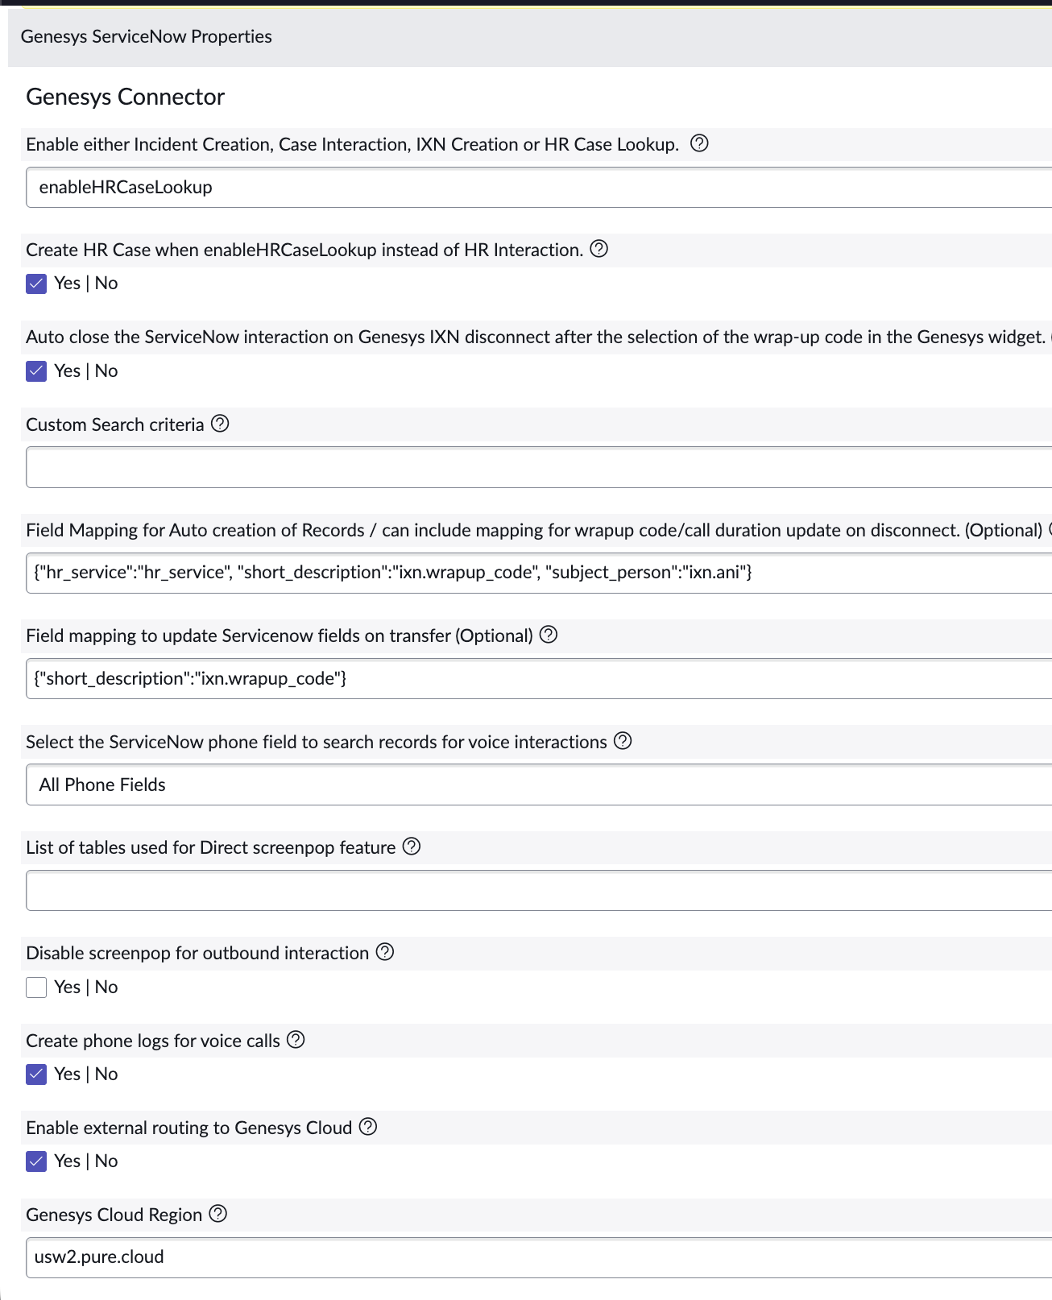  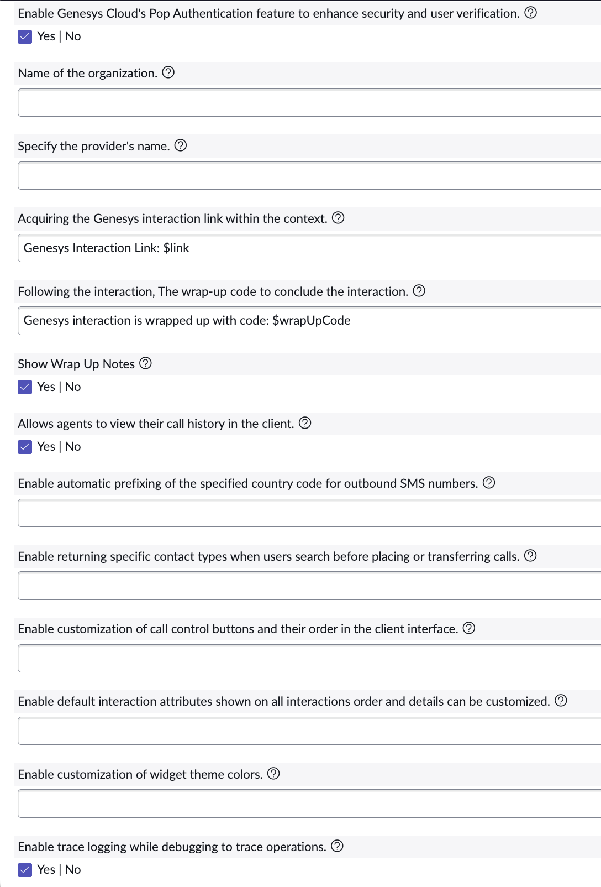

3.2 Authorize Genesys Cloud Connector OAuth Client in Genesys Cloud
Please follow the steps below within Genesys Cloud org to approve connector’s OAuth client.
- Go to Admin -> Integrations -> Authorized Applications.
- Search for ‘Servicenow connector’ in App Name and select the record.
- Check all the scopes and click on Save.

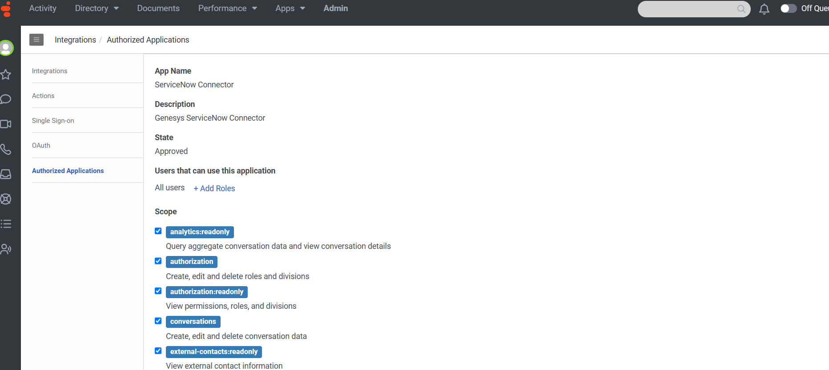

3.3 Configuring Agent Access to the Genesys Cloud Connector in Genesys Cloud
Please follow the steps below within Genesys Cloud org to assign agents with permissions to access ServiceNow connector within ServiceNow,

- Grant the permission ‘genesysSNow’ to the users who need access to the connector.
  - Go to Genesys Cloud Org
  - Under admin, click ‘Roles/Permissions’
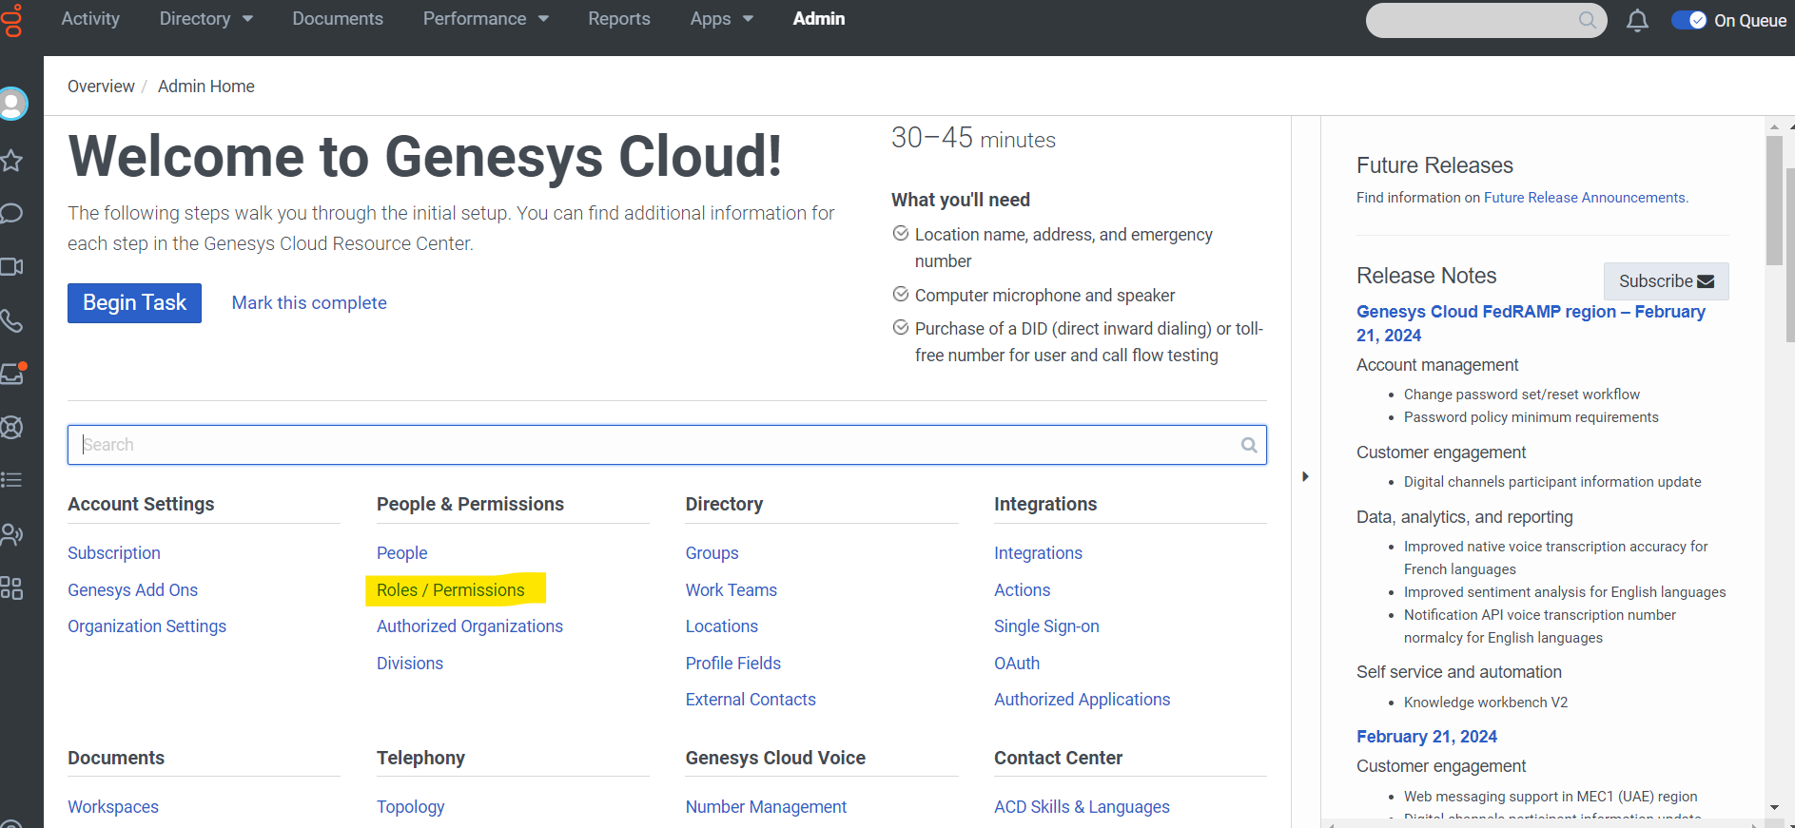

- You can create a new Role with the ‘genesysSNow’ permission and assign this role to the user or add this permission to the existing role.
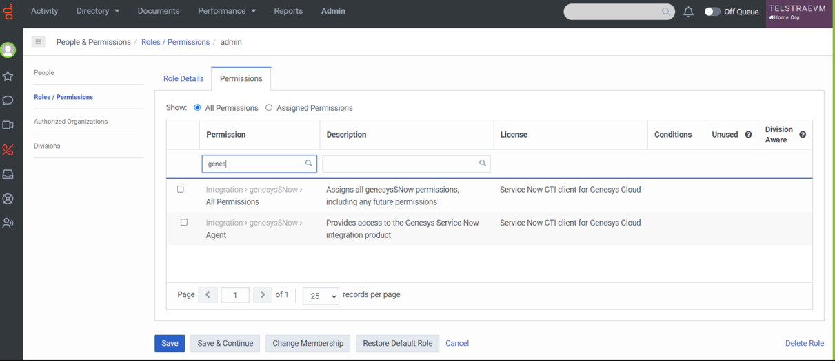

3.4 Configure Multiple OpenFrame Configurations
Global Genesys Connector properties can be overridden through the active OpenFrame configuration assigned to a ServiceNow user. Multiple OpenFrame configurations can be active at the same time.

Each OpenFrame configuration includes a configuration input field where property overrides can be defined. These values apply to all users who belong to the user group selected in the User Group field of that OpenFrame configuration.

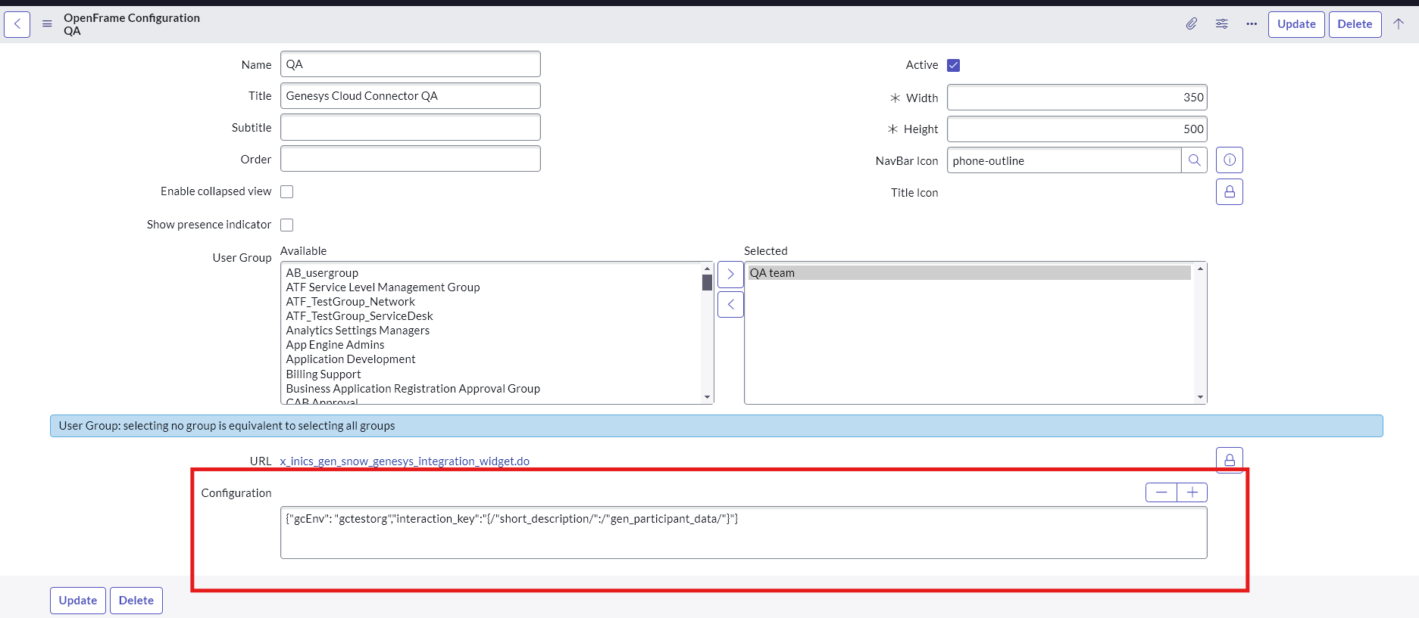

Use the following JSON format to override one or more connector properties:
{
"<property_key_name1>": "<value1>",
"<property_key_name2>": "<value2>"
}

Example:
{
"gcEnv": "gctestorg",
"interaction_key": "{\"short_description\":\"gen_participant_data\"}"
}

Property key names can be identified on the Global Properties page by hovering over the question mark icon next to the corresponding property.

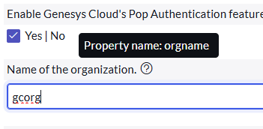

Both property names and values must be enclosed in double quotation marks.
When a property value is expected to be a JSON string, any double quotation marks within the value must be escaped using a backslash (\).
For example, the interaction_key property accepts a JSON value provided as an escaped JSON string, as shown above.

- Support and Troubleshooting
Genesys Cloud Connector Support is delivered by Genesys Professional Services (CAS) in collaboration with Customer Care through a seamless support process. Customers use the Customer Care support interface as a single point of contact and can request assistance through phone, email, or web channels.
ServiceNow Connector Support Guide

4.1 Service Level Agreement Definition
Custom Application Support process and SLA’s are defined here.

  - Troubleshooting
Configuration errors are recorded in the browser console with details that can help identify and correct invalid property values. When opening a support case with Genesys, include the browser and console logs to assist with the investigation.
For issues related to the embeddable widget, refer to the troubleshooting guide available at: https://help.mypurecloud.com/articles/troubleshoot-the-genesys-cloud-embedded-clients/

End of Document

